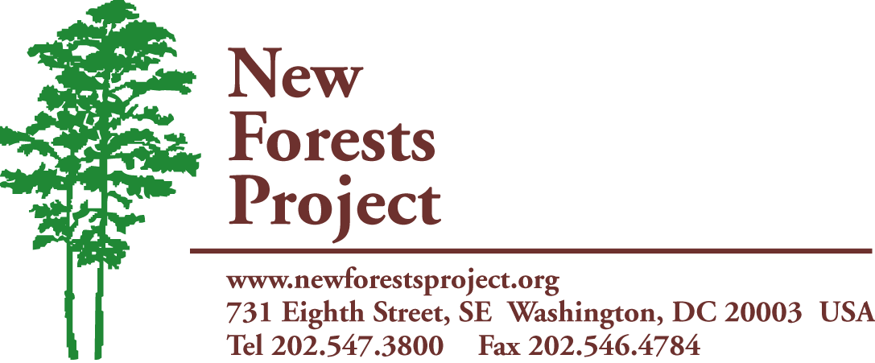
A Project of The International Center
www.newforestsproject.org

NEW FORESTS PROJECT UPDATE
June 2013

Small Grants Program

In 2013, NFP is focusing its resources on sending shipments of seeds until sufficient funding can be raised to provide small grants for identified programs. One way we hope to raise money for these small grants is through the upcoming mini proposal to NFP’s high and major donors. This appeal is going to focus on the efforts of Zimconserve Agroforestry Center is Seke, Zimbabwe. This organization is a long time reciepient of seeds from NFP and has recently begun a project integrating planting tree seeds and cook stoves.

Tree Seeds
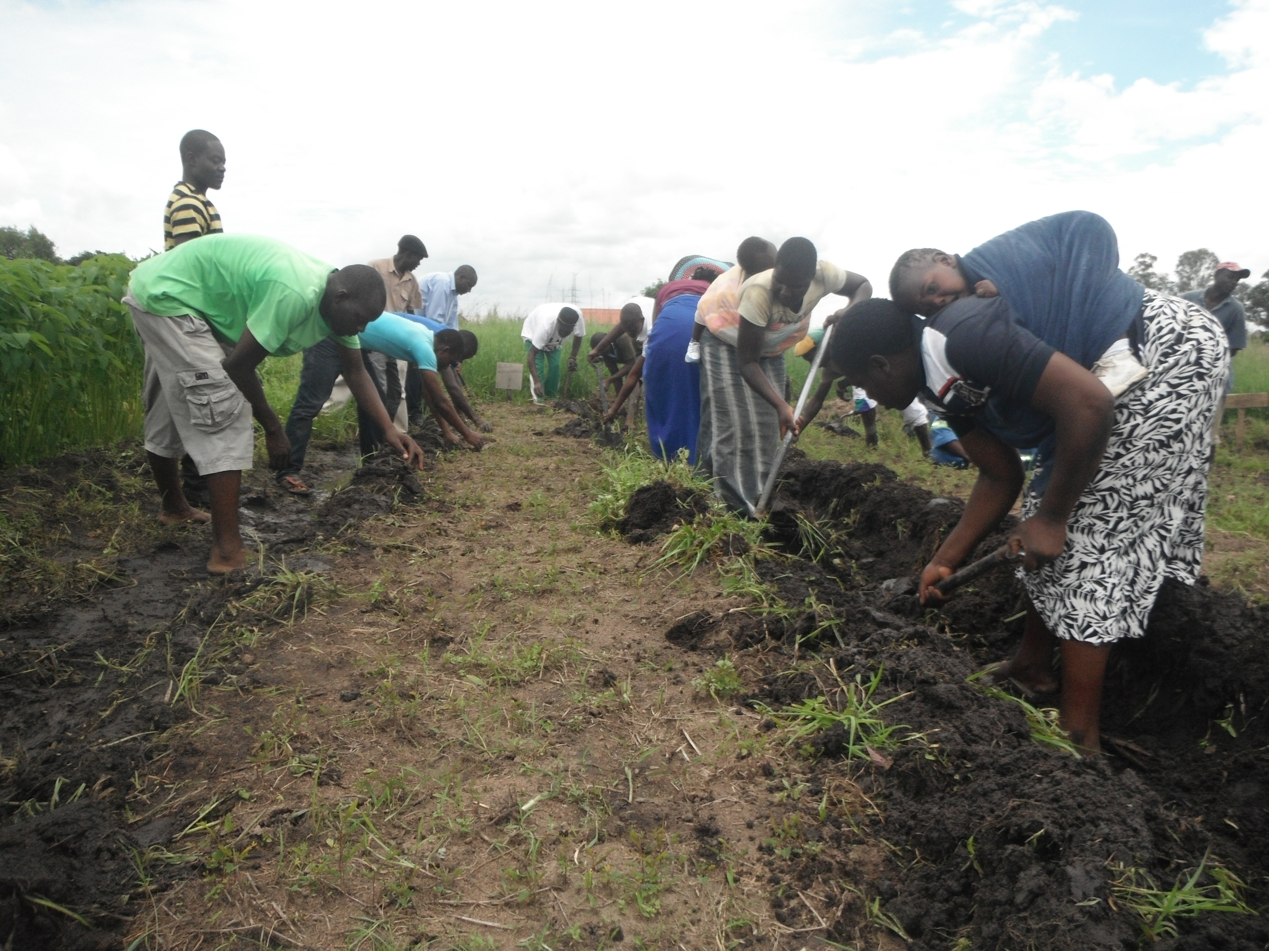
This year we have sent out 1 shipment of seeds to 7 organizations around the world. Countries benefiting from our seed program since our last update include Haiti, Burundi, Zimbabwe, Senegal, Kenya, and Cameroon. We have sent out over 130 pounds of seeds since our last update. In addition to the immense benefit of these seeds, many of these projects are working on ways to expand their programs to become more self-sufficient. NFP has long encouraged that organizations undertake in activities to improve their self-sufficiency using the seeds. An example of this would be the Zimconserve Agroforestry Center in Seke, Zimbabwe. After receiving 5kg of seeds in 2012, they have begun working on a program that is integrating tree planting and encouraging the use of fuel-efficient cook stoves. These cook stoves not only create 66% wood savings, allowing our seeds to last considerably longer, but they cut down on smoke related illnesses and severe burns. This project will be focused on in our upcoming mini-proposal with the hope of raising funds for a small grant that can be given to this organization to continue and expand this program. Recently, Zimconserve also sent in a report detailing how they are using our seed shipment. They were able to train over 900 families and 10 schools in their program on how to build nurseries and care for their trees, including the organic management of pests. Zimconserve will be receiving seeds in our next shipment in 2013.

For more information contact:
Joseph House
Email: jhouse@theintlcenter.org
Phone: 202-285-4328

